Experiment 4 — Scrum Project and Sprint Management in Jira

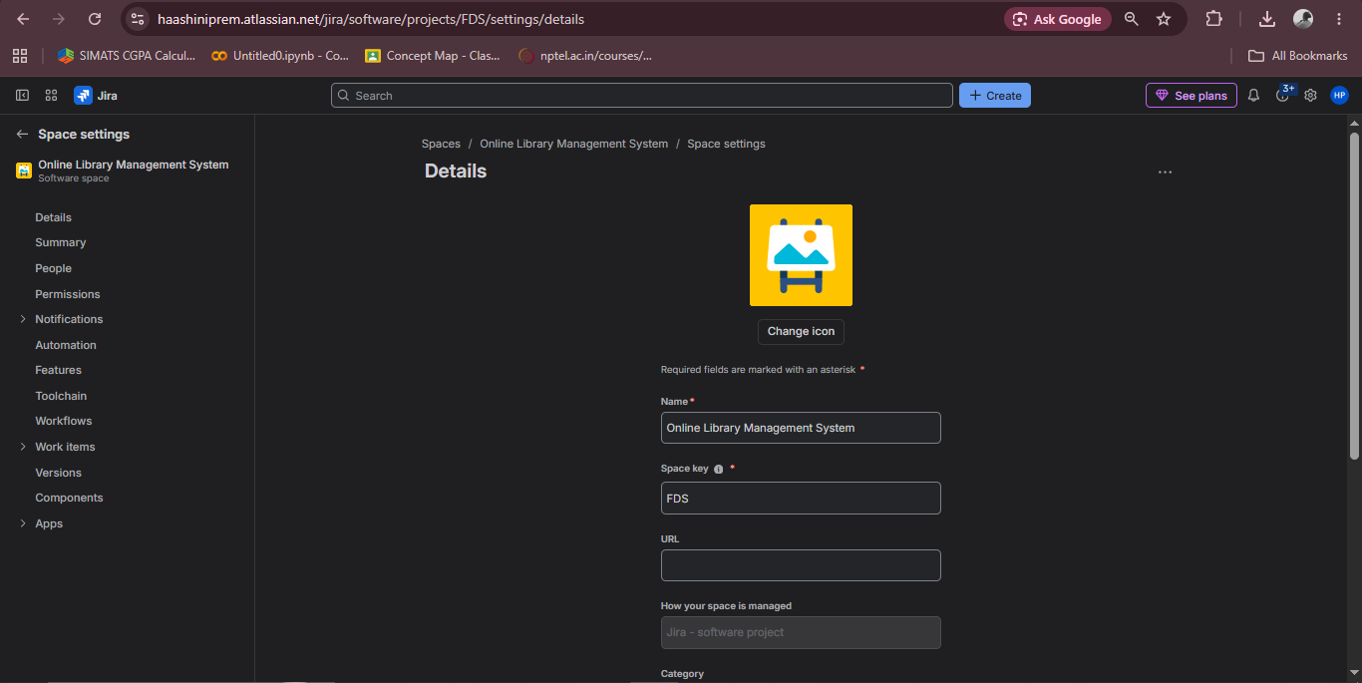
Step 1: Create a Scrum project

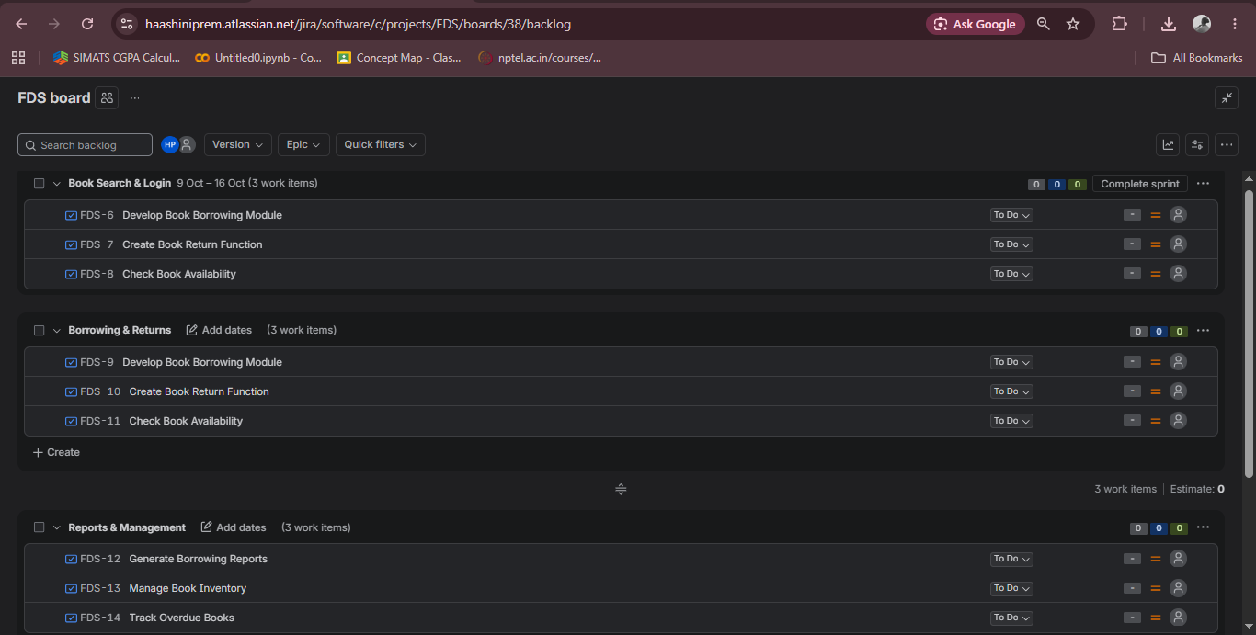
Step 2: Create three sprints

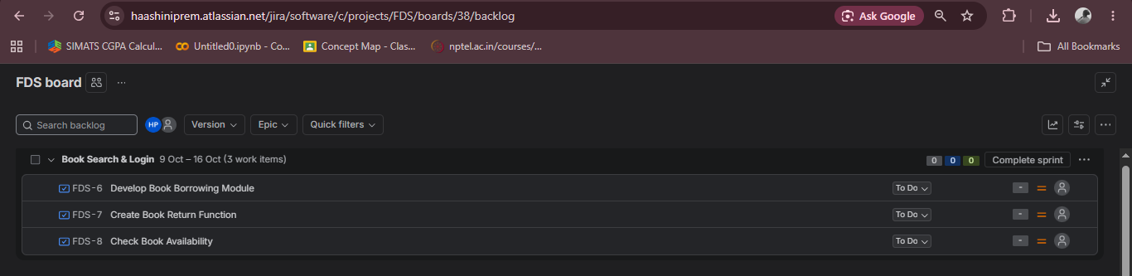
Step 3: Add tasks to Sprint 1

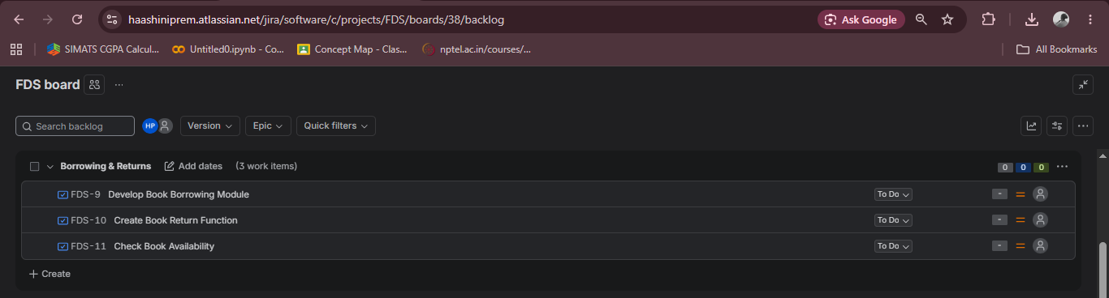
Step 4: Add tasks to Sprint 2

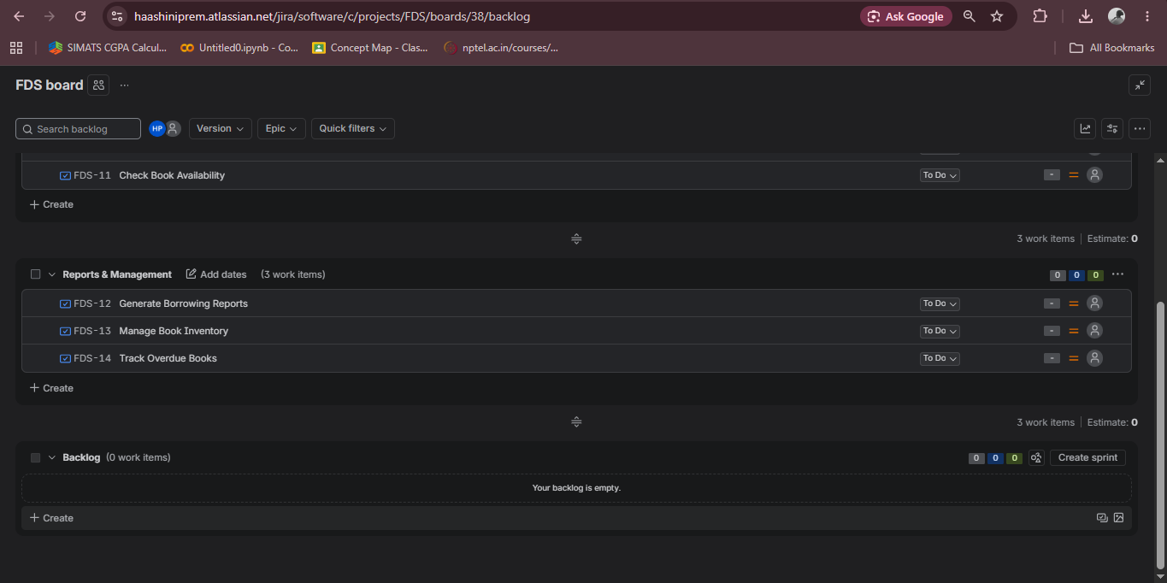
Step 5: Add tasks to Sprint 3

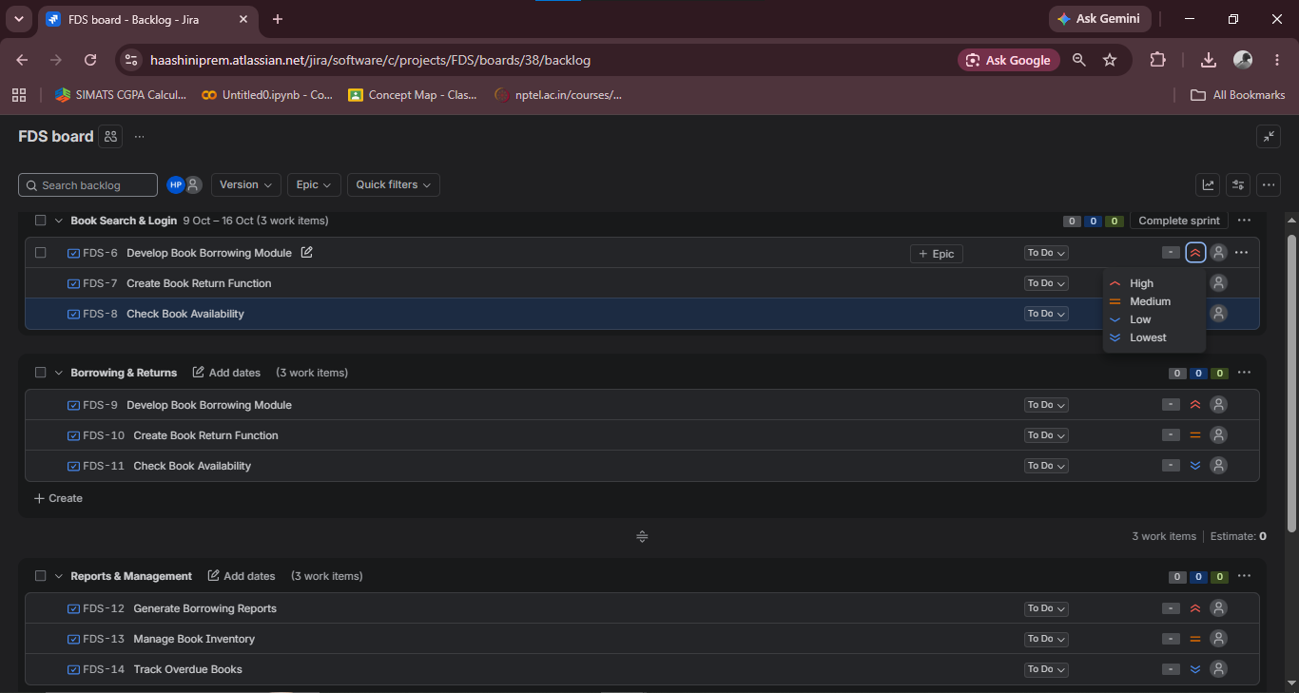
Step 6: Prioritize the backlog

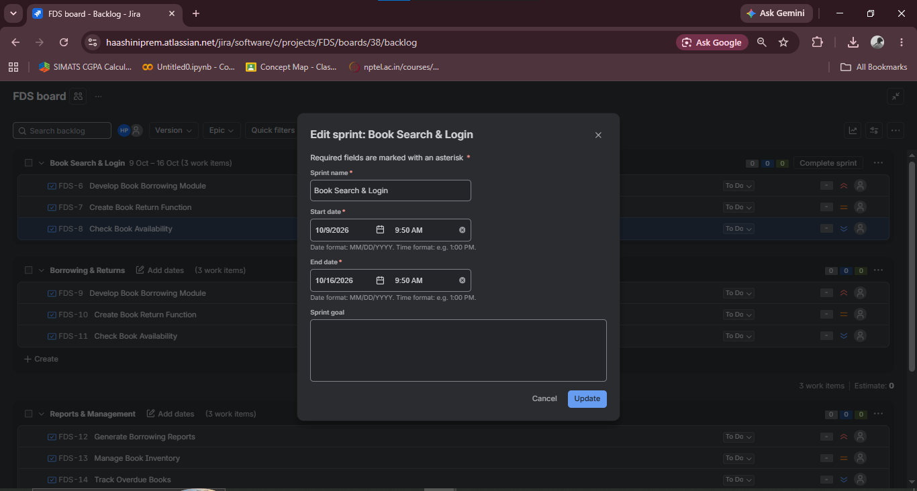
Step 7: Set the sprint duration

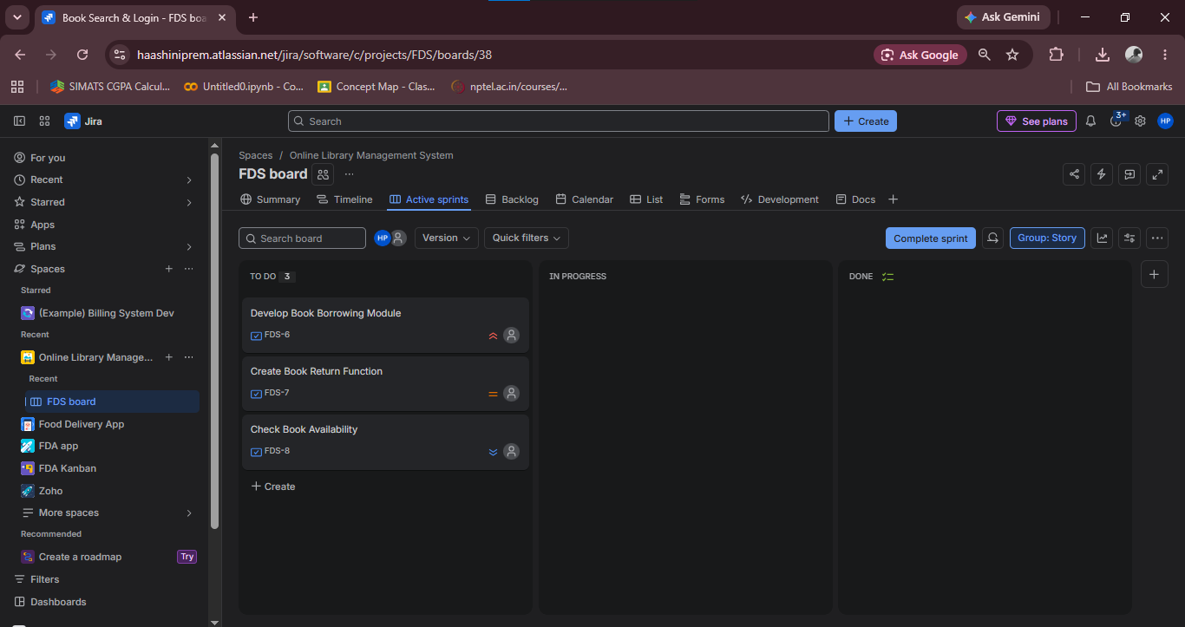
Step 8: Start the first sprint

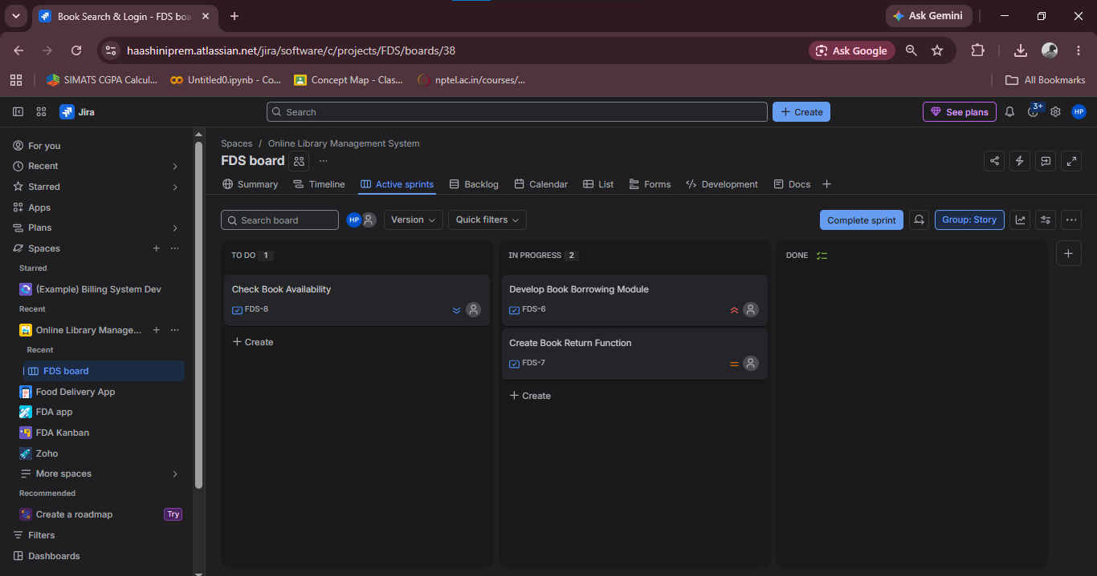
Step 9: Demonstrate task progress

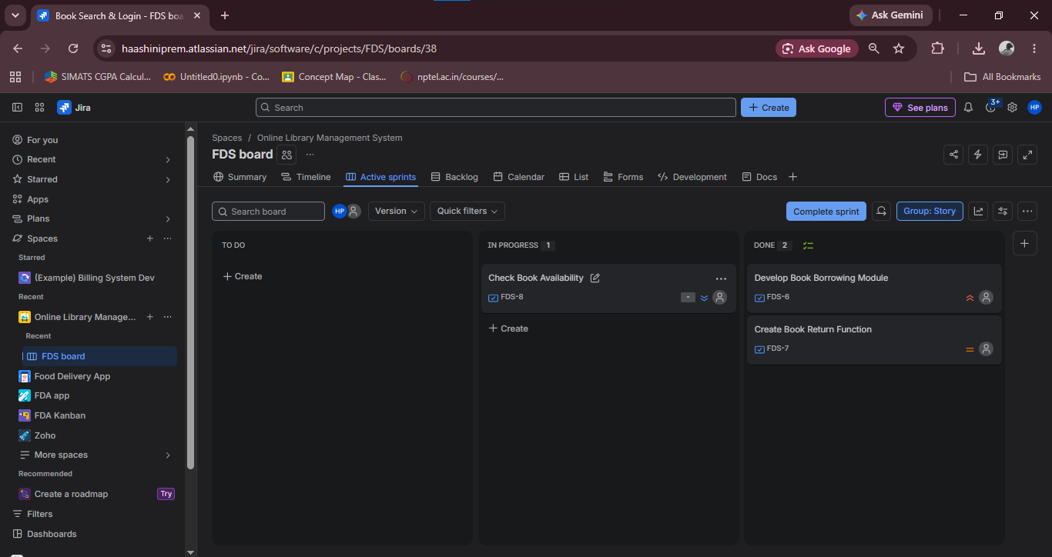
Step 10: Complete the tasks

